Dis-Indo-Sulawesi-Toraja 2

The Sa'dan-Toraja of South Sulawesi and their Traditional Water Buffalo Sacrifice Ceremony

The Sa'dan-Toraja, who live in Central and South Sulawesi, formerly known as the Celebes, speak an Austronesian, Malayo-Polynesian language and have an animist religion (Gordon 2005: 434). Their neighbors, the Bugis, are also an Austronesian-speaking people with an animist religion, Tolotang. Both groups had migrated to south Sulawesi around 2500 BCE from Taiwan after first emigrating from south China (Wen and Chen 2008). Thus, they were part of the Austronesian expansion that ultimately led to the Polynesian migrations into the Pacific islands. The Bugis call the Sa'dan-Toraja, To-ri-aja (To-ri-adja) that literally means “people from the interior” where there are many mountains up to 3,000 m high. So the Toraja are also considered mountain people. When the English arrived, they thought the Toraja’s name denoted a place “To” Raja”, but in Indonesian “raja” means "king" or "ruler,” so when the British referred to these people as people of raja they were in a sense called "people of high rank." To the Toraja, themselves, “raja” means “magnificent” or “handsome”. Thus, these three meanings of “Toraja” coalesce in referring to these people as “handsome people of high rank from the mountains”.

*Aluk To Dolo* is the traditional animist religion of the Toraja. In 1975 of 300,000 Torajans half practiced *Aluk To Dolo, and by* 1987 of 325,000 Torajans (Nooy-Palm in Eliade 1987, Vol. 14, 565), only 30 per cent were practicing *Aluk To Dolo.* Of the remainder 60 per cent were Christian and 10 per cent Muslim (Dalton 1988, 845). By 2016 perhaps some 20 percent are still practicing the old ways.

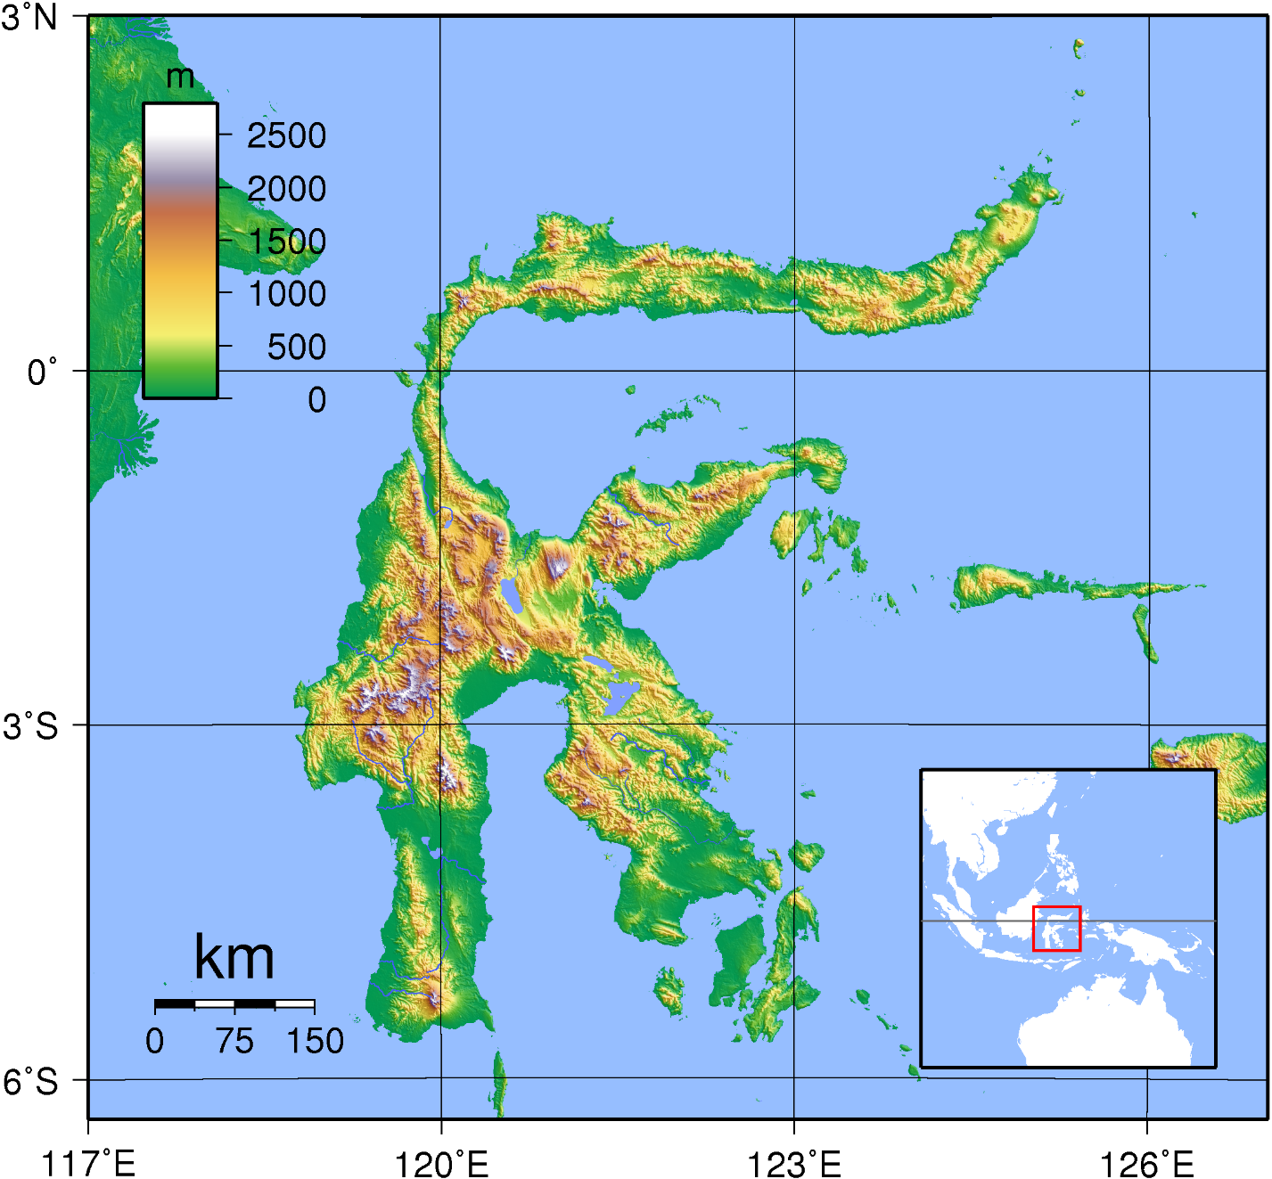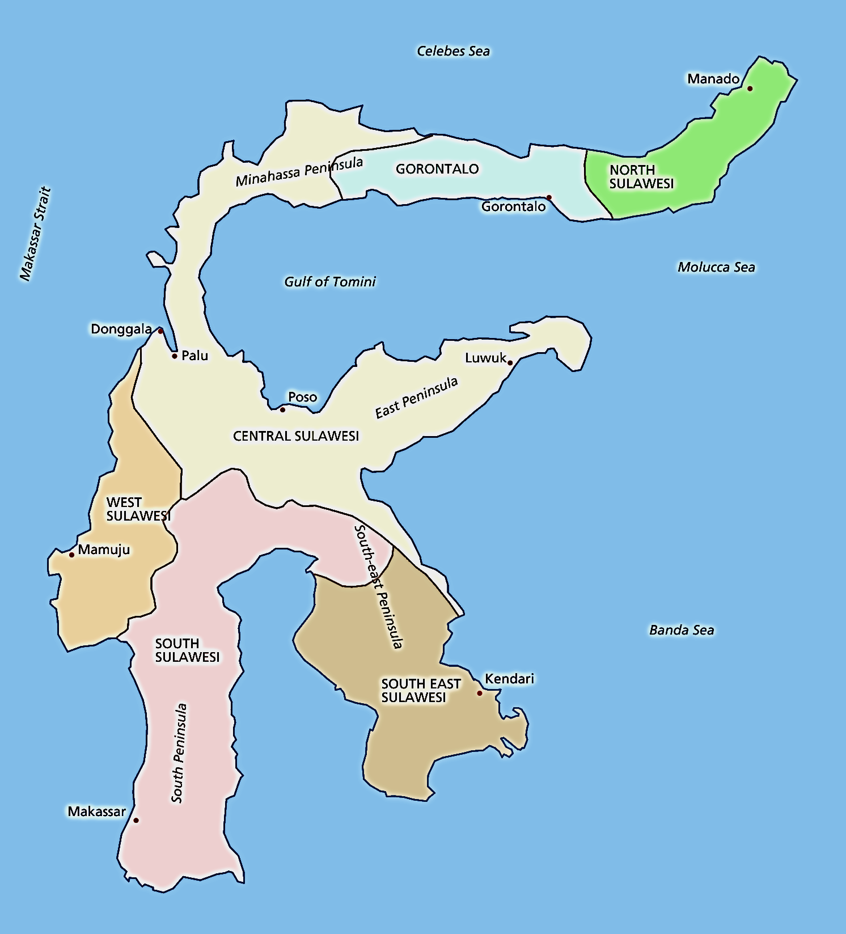

Fig. 1, a and b. Maps showing a) general location of Sulawesi in Indonesia and b) showing the location of Central and South Sulawesi where the Sa'dan-Toraja live.

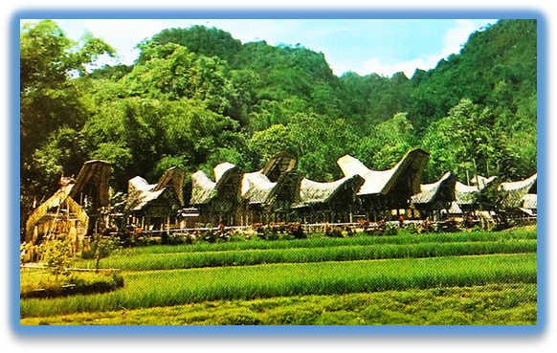

Fig. 2. Sa'dan-Toraja village of Ke Te in South Sulawesi on a post card ca. 1950 showing the mountainous landscape in the background, *tongkonan* houses in the midground and the wet-rice patties in the foreground. After <http://www.bendav.nl/gif/ebay/1425.jpg>.

*Tongkonan* housesare shaped like boats and all face north, symbolizing the legend that the first Torajans sailed in eight proas (high-prowed outriggers) from the mythical island of Pongko’ (“round earth mound”) southwest (i.e. from Taiwan ?) to South Sulawesi (Nooy-Palm 1979: 112-113). The word “*tongkonan*” derives from Torajan language *tongkon* (sit, stay, reside), so the *tongkonan* is where the first Torajans sat upon landing their outriggers and built the first *tongkonans,* and they still today reside in their *tongkonans* as the symbolic outrigger-shaped homes that are the centers of their social life.

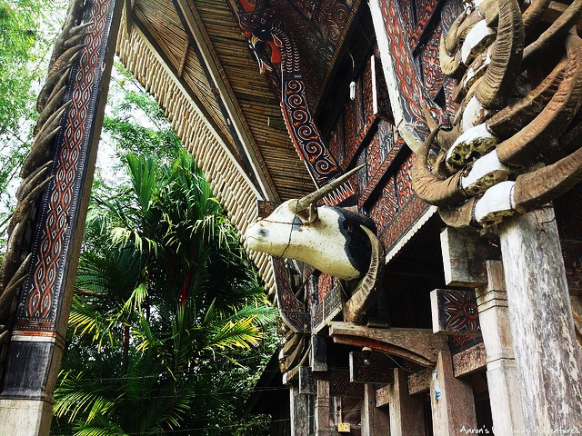

Fig. 3, Water buffalo horns and a carved water buffalo head adorn the exterior of a *tongkonan* in the village of Kete Kesu as an acknowledgement of the primal place the water buffalo holds in the religion the Toraja. From https://i2.wp.com/farm8.staticflickr.com/7351/10507178145_5b6a23bcf2_z.jpg?resize=640%2C480

Although *tongkonans* are family houses, the family does not usually live in them. Instead, they serve a ceremonial role and are used to store the embalmed corpse while the family has a chance to save up enough money for the funeral, costing thousands, or even tens of thousands of U.S. dollars. That process can take months, or even years! Extravagant funerals are what the Torajan people are really famed for, enormous events where the entire extended family and town show up to pay their respects and present offerings for sacrifice.

When a person dies Galumpang cloth, which has reddish hue combined with yellow and blue, is used, to cover the coffin. It shows two-directional arrowheads, symbolizing the dynamics of life. The house of the deceased, meanwhile, is encircled by a long strip of this red cloth (Kartiwa, 2007). Then the ritual of *pallulukan* or the blackening of clothes is done by the immediate family of the dead. The family would go to a prepared open space outside the village, or sometimes this might also take place at the space below the family’s house, which is set on stilts. A hole containing a mixture of water, soil, leaves of *bilante* shrubs and sweet potato has been prepared for the family, who would then dip their clothes there. A pig is sacrificed during the ritual and one of its ears is left in a bamboo hollow near the hole. Members of the family who are unable to come to the ritual could then come to the place, dip their finger in the hole and leave a black mark on the pig’s ear. The family should refrain from eating rice and only wear black until the seventh day after the burial, on which day the family visits the grave again for the first time. As they go back home, they would eat rice again and discard their black clothes. Their refraining from eating rice shows their solidarity with the dead, who would no longer be able to eat rice.

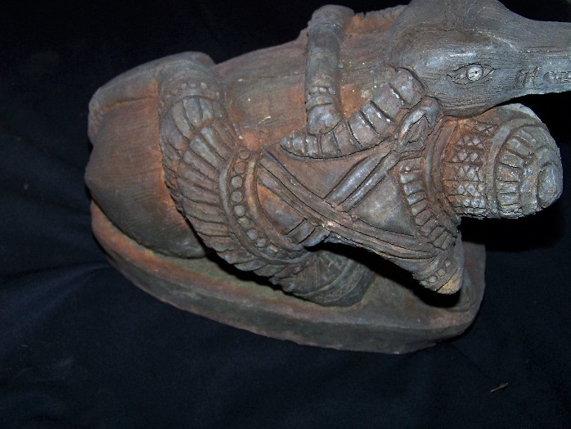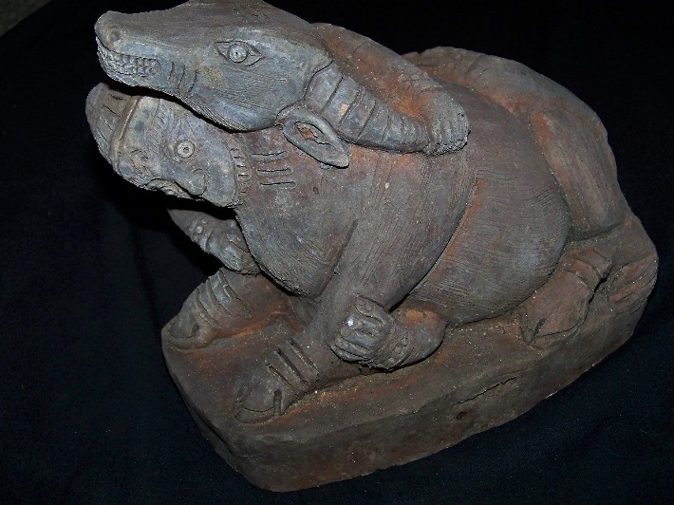

Fig. 4. Sa'dan-Toraja Water Buffalo Sacrifice Ceremony memorial sculpture, limestone, South Sulawesi, ca 1700,

Formal Label: Sa'dan-Toraja ***Ma’patinggorok Tedong*** (Water Buffalo Sacrifice Ceremony) memorial sculpture, limestone, South Sulawesi, ca 1700.

Accession Number: DS632.T7.A2

Date or Time Horizon: ca 1700

Geographical Area: South Sulawesi

Cultural Affiliation: Sa'dan-Toraja

Medium: limestone

Dimensions: L 9 in

Weight:

Provenance: The Bouck Estate, New York City, 1950-2013, then Ballston Spa, New York.

When a noble dies, a stone sculpted representation of the Water Buffalo Sacrificial Ceremony, like the one pictured above (Fig.4), would be commissioned and set in an honored place. Under the sculpture, a piece of iron and some yellow beads, *manik riri*, are placed, symbolizing metaphorically strength and wealth, in the hope that the family of the dead and the deceased as well would be strong and prosper both in this life and the next.

**Toraja religion**

Toraja religion, *aluk to dolo,* literally means “rituals of the ancients” and may go back to their Austronesian origins. *Aluk to dolo* is a complex mixture of ancestor cult, myth, and ritual. *Aluk To Dolo* was originally divided probably equally between a life half and a death half. The life half concerned fertility and was forbidden by the Christian missionaries, thus making the death half and the funeral more important as this was acceptable to the Church. It also skewed the traditional religious festivals in favor of death, dying and funeral rituals, which is what most tourists witness.

Despite the missionaries, followers of the ancient religion have been able to maintain their forms of worship, the fertility and life-affirming part albeit clandestinely. Toraja belief in the existence of gods of the sky and gods of the earth affirms that they are the powers to whom the followers have to give offerings and revere by following the traditional rituals, despite the Christian monotheistic teaching of ‘ and the Hebrew YHWH.

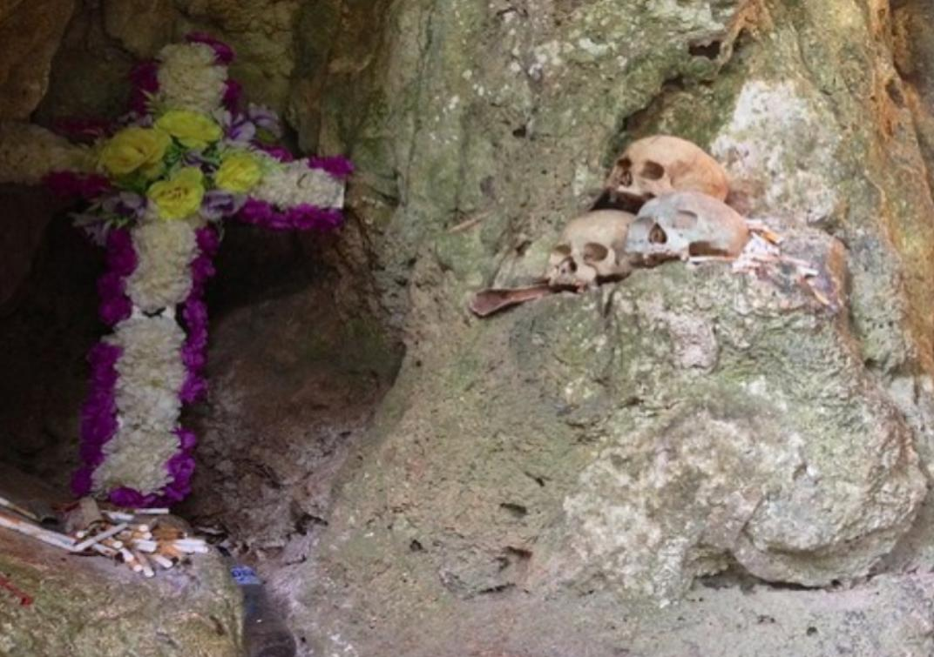

Fig. 5. A typical tomb at Londa Londa showing the syncretistic attitude the Toraja have toward Christianity and *aluk to dolo.* Here the skulls of the ancestors are on the right, which have been processedin the traditional way. On the left is a cross with two colors of flowers and cigarettes as offerings below. The two colors of the cross fulfills the requirements of *aluk to dolo* that two colors as found in nature make a sacred offering, like the *Tedong Tedong Bonga* or black and white water buffalo and the black and white heron.

A male healer, *tomebalun*, leads rituals directed to the gods of the sky while rituals directed to the gods of the earth are led by a female healer, the *to’burake*. The female healer wears a long red scarf, symbolizing the *to’barana* or the banyan tree, the gate to the realm of the earth gods. There is also a transgender *to’burake*, called the *to’burake tambolang*. “Tambolang” is actually the name of a heron with black and white colors. The presence of the two colors in one bird is seen as symbolizing a cosmic union, just as the identity of the *to’ burake tambolang* who is female and male simultaneously. *To’ burake tambolang* assists the female *to’ burake* in earth rituals, or rituals of life, directed to the east, the direction of life and the earth gods.

In major rituals the *to’ minaa*, a priest knowing tribal lore and history, recites a long mythic history of the genesis of the tribe which involves the Toraja cosmology that the cosmos is divided into an upper world, a world of man, and the underworld. At first heaven and earth were married together and there was darkness, then came separation and light. From this marriage emerged the gods. *Puang Matua*, " the old lord," is the god of heaven and the main deity while *Pong Banggai di Rante*, "the master of the plains," is the god of earth. *Pong Tulak Padang* carries the earth in the palms of his hands and with *Puang Matua* he maintains the equilibrium of earth and separates day and night. But his bad-tempered wife *Indo' Ongon-ongon* can cause earthquakes and upset the equilibrium. Another feared god is *Pong Lalondong*, "the lord who is a raptor," who judges the dead. In some societies, raptors are left to excarnate or deflesh the bones of the dead and so ingest the wisdom and the spirit of the deceased by literally eating their flesh and blood, which is made metaphoric in the Christian eucharist with bread and wine. This may be intended here. Between heaven and earth is *Gaun ti Kembong*, "the swollen cloud" from which emanates *Puang Matua*, somewhat like the Hebrew YHWH. There may be some interplay between the Toraja and the missionaries’ teachings here. The goddess of medicine is *Indo' Belo Tumbang*, "the lady who dances beautifully." There are other gods in the upper world and the underworld, and on earth there are deities and spirits, who live in rivers, wells, trees, and stones. This is truly panentheism with the divine’s spirit inhering in the material natural world.

Humanity's role is to help maintain equilibrium between the upper world and the underworld by observing the proper rituals. There are two divisions of rituals. The *Rambu Tuka*, the Rising Sun or Smoke Ascending rituals are associated with the north and east, with joy and life. This includes rituals for birth, marriage, health, the house, the community, and rice. The *Rambu Solo'*, the Setting Sun or Smoke Descending rituals are associated with the south and west, with darkness, night, and death. Healing rituals partake of both divisions. The most important *Rambu Tuka* ritual is the Bua' feast in which the *buraka*, a priestess or hermaphrodite priest, petitions the gods of heaven to look after the community. The *Merok* feast is for the benefit of a large family. *Rambu Solo'* rituals include great death feasts at funerals conducted by the death priest. These funerals are now the main feature of Toraja religion due to the ban the Christians have imposed on the fertility and life affirming rites. Display of wealth is important for Torajans believe they will live in the afterworld as they do on earth, and the souls of sacrificed water buffalo will follow their masters to heaven and be helpers to them there in their new life.

***Ma’patinggorok Tedong***

Another aspect of Toraja religion is the reverence they hold for the water buffalo. The sacrifice of water buffalos or ***Ma’patinggorok Tedong,*** a central event held at the decease of an elder. The most valued water buffalo is the black and white or Tedong Tedong bonga, because of its combination of two colors, like the heron.Torajans believe thatthe spirit needs the water buffalo in order to attain *Puya or* making a spiritual connection with the divine. Indeed, it is believed thatwhen more water buffalos are sacrificed *Puya* is achieved sooner. The afterworld is also *Puya*, "a land of souls," which is to the southwest and under the earth. By a lavish death feast the deceased will reach *Puya*. He is judged by *Pong Lalondong* and then climbs a mountain to reach heaven, where he joins the deified ancestors as a constellation which guards mankind and the rice. *Rambu Solo* will be more festivewhen the deceased is a descendant of a king or a wealthy person; thisappears from the amount of sacrificed water buffalo and pigs, this will be a measurement of their wealth and rank when they were still alive. Building tomb for family members that have passed away and having *Rambu Solo*’ ceremony usually needs hundreds of million up to billions of Rupiah. No less than 150 animals are needed for the sacrifice, which consists of water buffalos and pigs. Family members will share water buffalo and pigs meat to neighbors who have helped them with the *Rambu Solo*’ ceremony.

.

Fig. 5. *Tedong Tedong Bonga* or black and white water buffalo that has an important role in *Ma’patinggorok Tedong* and is a symbol of prestige in Torajan society. Photo : Aris Setiawan

*Ma’patinggorok Tedong* is a ceremony where water buffalos are sacrificed using *parang* or long machete in one cut. *Tedong*, is the Toraja name for water buffalos, *Bubalus bubalis*, which is the only species available. There are two kinds of *tedong*, a black *tedong* and *tedong tedong bonga,* black and white. The price of a black *tedong* is around 10-25 million rupiahs, and that of a *tedong tedong bonga* is perhaps ten times as much. Purportedly, once someone tried to take a *tedong tedong bonga* out of Tana Toraja, but it was found that this species cannot survive out of the Toraja domain, due to exhaustion or a difference in temperature. Some also believe it was due to mythical reasons. For Torajans who can afford to have a ceremony by sacrificing a *tedong tedong bonga*, this will increase the level of prestige in the society.

*Tongkonans* are decorated with special carvings in multi-colored compositions that consist of red, white, black and yellow that reflect the *Aluk To Dolo* belief that each color has its own meaning and purpose according to Torajan color philosophy. Red and white are colors that symbolize the life of a human and can be used anywhere and at any time, in traditional ceremonies and even in daily life. Yellow is the color of glory and as a symbol of divinity which is used in the *Rambu Tuka*’ ceremony for the welfare of mankind. Meanwhile, black is the symbol of death or darkness and is worn during the *Rambu Solo*’ ceremony (death ceremony). The meaning of the color of black in the base of every *Passura*’ (carving) is that each life contains of death, because in the view of *Aluk To Dolo*, that this world is only a temporary place to stay. (Source: [http://budayatoraja](http://budayatoraja/). tripod.com/Ukiran.htm)

The design of *Tongkonans* reflect caste differences through the use of color. The Torajas recognize four castes: the noble or gold caste (descendants of the gods); the iron caste (from which come “the brave men” or the *tobarani* who would lead wars and head hunting missions); the *tana’ karurun* or sugar palm caste (most people are from these caste); and *tana’ koa koa* or the shrub caste, the former slaves.

For instance, the house of a noble, a gold caste, is called *banua’ sura*, painted black with colored carvings. The house of a member of the iron caste is called *banua’ bolong* or the black house, painted black with no decorations. Wooden houses of the two lowest castes are not painted (Buijs, 2009).

Toraja house carvings are done over a black background in three colors: red,

yellow and white. Red symbolizes blood, and the color is made from red soil containing iron ochre

with vinegar as a binder. White symbolizes human bones and flesh; the color is made from kaolin clay.

Yellow is made from yellow soil (limonite ore) with a binder of fermented palm juice. (See: <http://mazeka82.files.wordpress.com/2011/04/perkmb-int-tradisional-tana-toraja.pdf>)



Fig. 6. An example of a brightly colored *banua’ sura tongkonan.*

It should also be remembered animals such as the *Tedong Tedong Bonga* or black and white water buffalo and birds such as the black and white heron are also prized as especially sacred for their multi colors.

**Death and the Toraja**

Death is an important matter for Torajans. *Rambu Solo*’ is a ritual of escorting the corpse from *rante* (burial) to the tombor *patane*. The corpse is believed to be able to walk due to the prayers to the

ancestors and the spirit. However, this ritual is slowly disregarded since many of Torajans now believe in Christian and Islam teachings. However, this ritual can still be found in the rural areas of Tana Toraja. Historically, Torajans are used to exploring the mountains on bare feet so the tradition of having the corpse do the same suggests that this emulates its transition to another type of spiritual existence.

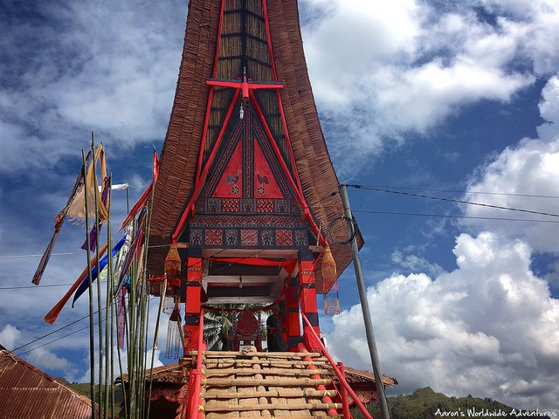

Fig. 7. This special, centrally located charnel house is where the corpse was walked to. It holds the casket in which the corpse was laid on the second level. From https://i0.wp.com/farm6.staticflickr.com/5532/10586171406_fdbfa7b77e_z.jpg?resize=640%2C480

After the emplacement of the corpse in the charnel house, the ***Ma’patinggorok Tedong*** can get under way. The first thing to decide on is who is the person to do the sacrifice of the water buffalo. A picture of a likely candidate is found on the following photo taken in the 1920’s. It takes great strength to do the job properly without the animal struggling too much.

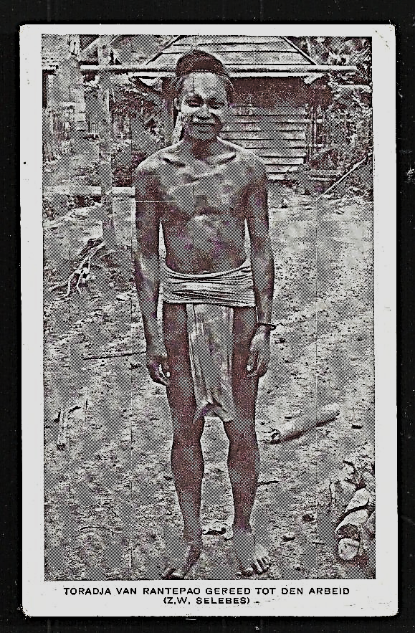

Fig. 8. Sa'dan-Toraja of Rantepao of **Toraja Utara**, a regency (*kabupaten*) of South Sulawesi Province of Indonesia, a home of the Toraja ethnic group, dressed with a traditional loin cloth and woven cap, which he would have worn in the traditional Water Buffalo Sacrifice Ceremony, in a postcard ca. 1920’s by Drukkerij van Lonkhuyzen of Zeis, Netherlands.

The next thing that has to be done is to prepare the Water Buffalo’s crypt door, which symbolically establishes a place of great sanctity next to the newly deceased person.

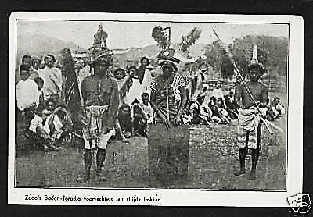

Fig. 9. Sa'dan-Toraja communal gathering with a Water Buffalo Crypt Door that is to be ceremonially installed, in a postcard ca. 1920’s by Drukkerij van Lonkhuyzen of Zeis, Netherlands.

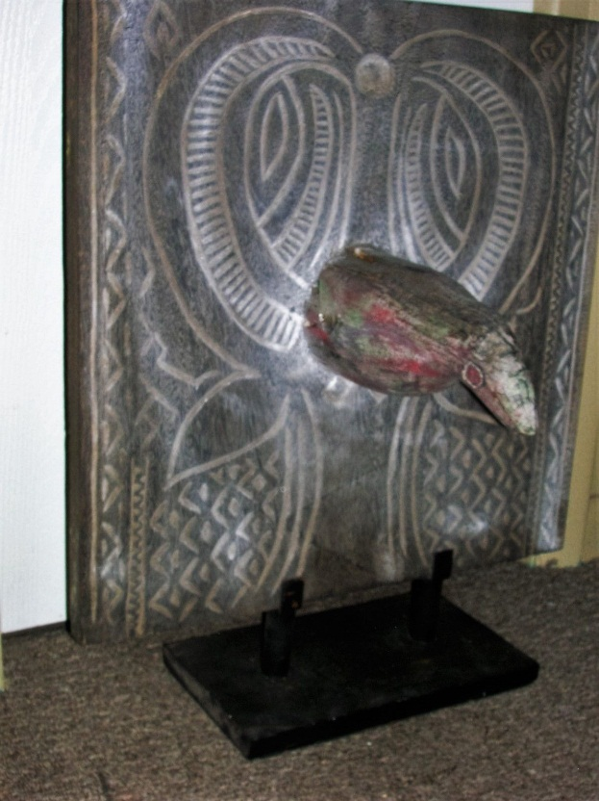

Fig. 10. Sa'dan-Toraja Water Buffalo Crypt Door, South Sulawesi

This Sa'dan-Toraja Water Buffalo Crypt Door with the horns of the water buffalo pointing up and the head and a third horn also pointing down (to signify death) protruding from the forehead of the water buffalo (the source of its spirit). The chevron geometrics in black and white signify the purifying blood that issued forth from the sacrificial buffalo, which sanctified the spirits in the adjacent human tombs as well.

Formal Label: Sa'dan-Toraja Water Buffalo Crypt Door, South Sulawesi.

Accession Number: DS632.T7.A2

Date or Time Horizon: early 1900’s

Geographical Area: South Sulawesi

Cultural Affiliation: Sa'dan-Toraja

Media: wood, horn, kaolin paint, red ochre paint

Dimensions: H 24 in

Weight:

Provenance: the Robert Cornell estate, New York.

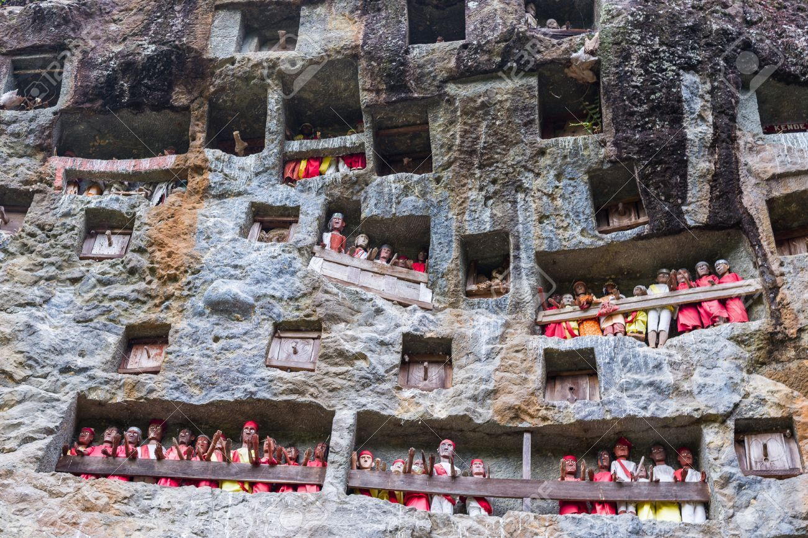

Fig. 11. Photograph showing the exquisite expanse of a white-washed limestone cliff wall at Londa Londa to keep the funeral remains of individual *liangs* or family groups and their tombs (*patanes*) and their *tau taus* or wooden effigies of the spirits of the dead safe from robbers. Above and to the right of these *tau taus* are nine Water Buffalo Crypt Doors with protruding water buffalo horns nIt is thought that the spirits of the water buffalo still inhere in their physical remains and act as sanctifying presences. After <http://i.ebayimg.com/images/g/s6UAAOSwbYZXVxUX/s-l400.jpg>

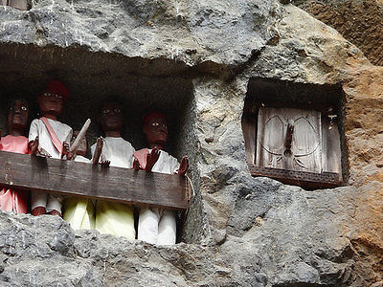

Fig. 12. Detail showing a *liang* and a group of *tau taus* (left) and a Water Buffalo Crypt Door (right) with one horn protruding as a handle. After <http://i.ebayimg.com/images/g/s6UAAOSwbYZXVxUX/s-l400.jpg>

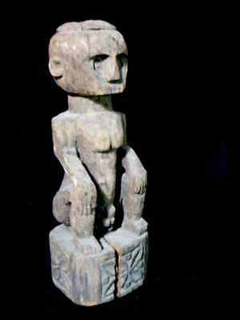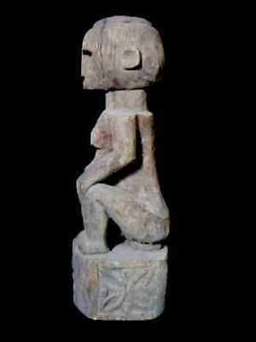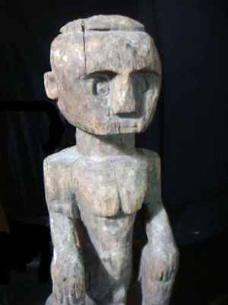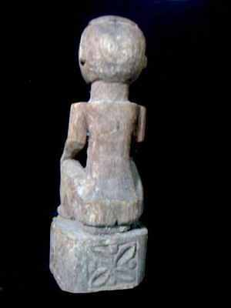

Fig. 13. Toraja Grave Guardian from South Sulawesi, Indonesia, Atlantika DS632.T7.A1.

Formal Label: Toraja Grave Guardian from South Sulawesi, Indonesia

Accession Number: DS632.T7.A1

Date or Time Horizon: early 20th century

Geographical Area: South Sulawesi

Cultural Affiliation: Toraja

Medium: wood, patina of the figure is brownish-gray

Dimensions: H 30 in / 72 cm

Weight:

Provenance: from a grave priest

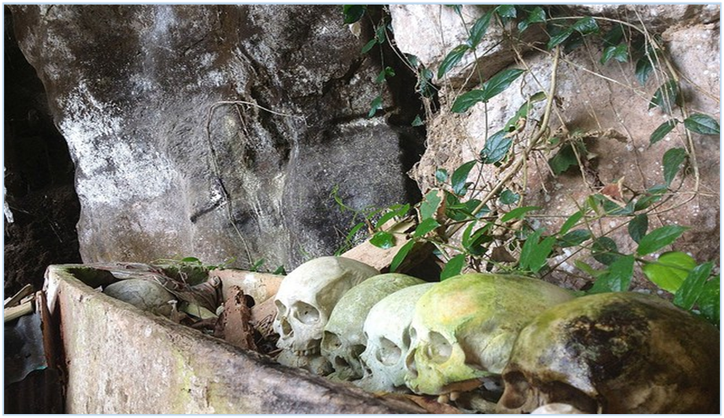

Fig. 14. The deceased has been finally “walked to” his resting place inside a burial cave or *patane* at Londa Londa along with his predecessors’ skulls and remains.

Managing the spirits of the dead is an important matter for Torajans and much work goes into making each funeral a success. *Rambu Solo*’ is a ritual of escorting the corpse from *rante* charnel house to the tombor *patane*. The corpse is believed to be able to walk due to the prayers to the ancestors and their spirits so these high and remote *patanes* on the faces of limestone cliffs act as safeguards preventing spirits of the dead from wandering too far!

References

Gordon, Raymond G., Jr, ed. 2005. *Ethnologue: Languages of the World*. 15th ed. Dallas: SIL International.

Li, H; Wen, B; Chen, SJ; et al. (2008). ["Paternal genetic affinity between Western Austronesians and Daic populations"](http://www.ncbi.nlm.nih.gov/pmc/articles/PMC2408594/figure/F1/). BMC Evol. Biol. **8**: 146.